What did Jesus mean when He said, “It is finished.”?

What are some reasons people are anti-Catholic?

First stage in his Discovery process
Contrast Old Testament Seder Meal/traditions to Jesus’ celebration of Passover
ACTIVITY: Moses instructed to find unblemished male lambs to slaughter and blood sprinkled on doorpost then eats the roasted lamb standing up
MARKER: Covenant sealed between God and Israel through animal sacrifice and a communion meal
To Hebrews, was a COVENANT, much more than a contract – was SACRED FAMILY BOND between Yahweh and Hebrews
In Jeremiah, Ezekiel 16, Hosea – all signify family bond between God and His people
NOTES

The Passover Feast
The Four “I will…” Cups of the Passover (Exodus 6: 6–7)
1st Sanctification: “I will bring you out from under the burdens of the Egyptians.”
2nd Judgment: “I will rescue you from their bondage.”
3rd Redemption: “I will redeem you with an outstretched arm.”
4th Praise: “I will take you as My people.”
After 3rd cup passed and they have finished the singing and praising, Jesus and Apostles left for Gethsemane. They never partook of the 4th cup which is the sealing of the covenant. This is the climax of the Passover…without the 4th cup there is no covenant

Who did Jesus say that He is? (after drinking the 3rd cup?)
“Truly I say to you, I shall not drink again of the fruit of the vine until that day when I drink it new in the kingdom.” Mark 14:25-32; 1Corinthians10:16; Matthew 26:39
NOTES

Second stage of the Discovery process
Jesus and the Passover meal; Jesus’ intentionality of His comments

Jesus’ prayer in the garden “My Father, if it be possible, let this cup pass from me…” what cup is He talking about?(Ref: Isaiah 51:17, Jeremiah 25:15 – Prophets refer to the “cup of wrath” that certain people have to drink down to the dregs because of their sin)
NOTES

Third stage of the Discovery process
The Kingdom
Scripture references focused on John 18: 33 -37, John 19:14, John12: 23–24, Exodus 28:4, Leviticus 16:4, John 19:33–36, Exodus 12:46, John1:29
Key Points: Background to understand what Jesus is doing on the cross
John understood Jesus’ kingdom not political or military but manifestation of mercy and Divine love
At the Jordan, John calls Jesus the “Behold the Lamb of God who takes away the sins of the world”. Throughout John’s gospel, Jesus is presented as Passover Lamb of NEW COVENANT
Jesus’ speaks of time of judgment of the world when ruler and king cast out
John19:14 – Jesus’ garment is a Greek tunic, a seamless one-piece garment. Same as described in Exodus and Leviticus to describe what high priest would wear when sacrificing the Passover lamb.
Correlation is Jesus is both high priest and victim (lamb) but not lamb of man but lamb of God
John also noted that Jesus was only one crucified that day without broken bones as was God’s demand for the unblemished lamb from flock to sacrifice as the Passover lamb. (John 19: 33-36, Exodus 12:46)
John notes it is the sixth hour of the day of preparation at precisely the time when Passover lamb was to be slain Jesus was sentenced to die.
NOTES

The Sacrifice
Carrying of the cross: Jesus offered Gall or Myrrh (opiates, pain killers) and refused them (remember He had said “I will not taste the fruit of the vine until my kingdom is manifested)
Suffering on the cross: Jesus offered sour wine on a Hyssop branch (same branch stipulated in Exodus 12 as branch to sprinkle lambs blood on the door posts) John is only one that says he took the sour wine and then said “It is finished.” Then He died.)
He received the 4th cup; He became the Passover Lamb of the New Covenant…Jesus interrupted the Old Covenant Passover to bring about the completion and transformation of that into the New Covenant Passover!
NOTES

Passover beginning and end
Question: When does Jesus sacrifice begin?
When celebrating the Old Covenant Passover by symbolically separating His body and blood (when that happens to humans, we die) but Jesus transforms them

Question: When does Jesus sacrifice end?
When Jesus receives the wine of the 4th cup, the cup of consummation (definition: A contract is said to be consummated, when everything to be done in relation to it, has been accomplished; finalizing of a contract or in this case, the covenant.) John 6:52-56
NOTES

Fourth stage of Discovery Process
If Passover represents beginning of Jesus’ sacrifice and Calvary represents end of the Passover for Him as the 4th Cup, then there is something more that remains for us – when do we go about celebrating the Passover (of the New Covenant)?

Review of night of Passover in Egypt: Was not enough that the unblemished lamb (with no broken bones) was slaughtered or its blood sprinkled on the doorpost or they ate unleavened bread and bitter herbs but had to actually EAT the roasted lamb – if not eat the lamb, then firstborn would die before the next morning.

Major revelation: “…the whole purpose behind Jesus’ resurrection and ascension and outpouring of Holy Spirit is God making the Lamb of God universally distributable so that we may ALL feast upon Christ the priest and victim.” Major finding as a non-Catholic: Baltimore Catechism explained how the entire Liturgy of the Eucharist is based upon the Passover!
Revelation chapter 5 – end is description of heavenly liturgy celebrated by a priest (symbolized by the Lamb)
NOTES

Conclusion
The Mass is based upon the Liturgy of Heaven which is the New Covenant
To understand that the Mass is rooted and grounded in the Bible, must use the Old and New Testament. Where most Christians do not understand – Christ is both celebrant and meal, Host and Victim but does not bleed or suffer or die anymore. Catholics receive the body of the GLORIFIED Lamb of God

We do not understand what we have been given. Many Catholics in Bible Studies are studying the menu not enjoying the meal, don’t know the recipe or the ingredients, not soaking ourselves in Sacred Scripture.

What is happening to us? America has 20-25 million Catholics, but second largest denomination is fallen away Catholics – 15 million not coming to dinner.
We receive enough grace to make us all saints from one Holy Communion.
How do we prepare before we go to Mass?
How do we prepare to receive in all the fullness of a megaton of grace dynamite?
But we are asleep at the wheel – sitting on top of Fort Knox – not tapping the treasure that is ours by birthright (as co-heirs with Christ, God’s children)
NOTES

Let us Pray
We pray, Almighty God, our Heavenly Father, we thank you for the covenant that you’ve established through Jesus Christ. In His body and His blood, we have a family bond that unites us to you. O Blessed Trinity – Father, Son and Holy Spirit. We wish to be enveloped in your love and your communion of life. Yet we are weak, we are ignorant, we are sinful. We are miserable wretches who can’t even admit it to ourselves. Have pity on us, O Lord, look upon your wayward children. We’re so proud of our technology, our material wealth, of our economic and political strength – have pity on us. Give us new grace; show us more mercy. Cause us to come back with far holier dispositions to receive the fullness of grace even as we receive the whole Christ.

I pray, O Lord, for your Holy Spirit to move in our hearts to soften them; to move in our minds, to toughen them by making us understand and believe and love the truth which Christ revealed; the Truth, which Christ embodies. You know each person here today and what they are afflicted with, what they suffer from, whether it’s their marriage, their family or their job or it is a bodily ailment.

Show us O Lord, how close you really are in the Holy Eucharist that we might fly to thee. That we might gain all the help we need from thee. Forgive us also for our waywardness and our ingratitude because we’ve taken them for granted for so long.

You died, Lord Jesus, to make us one family and now you live to sanctify us and make us holy. May it be, Lord Jesus; may it be.
Our Father…
Hail Mary…

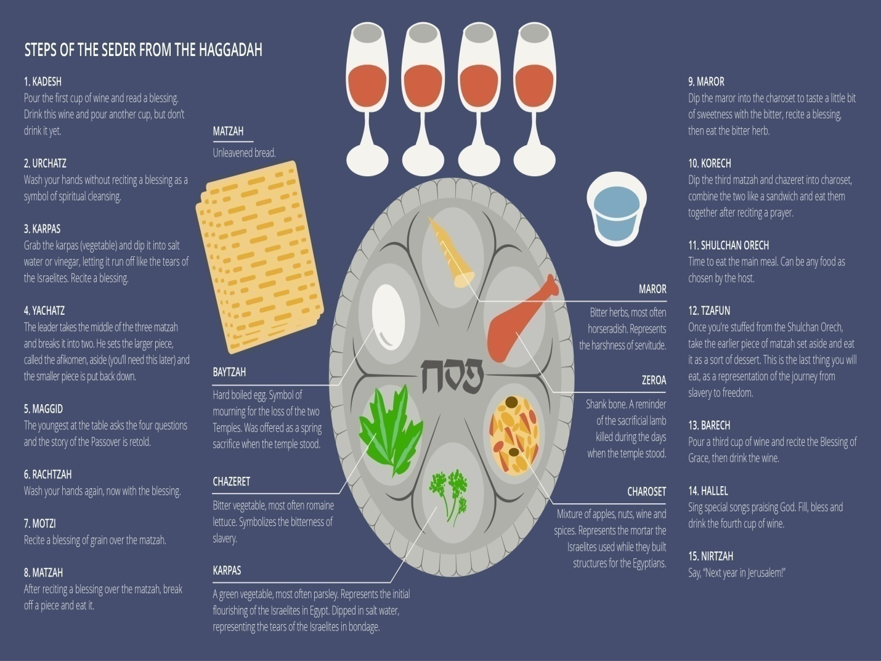
14. The Great Hillel – Sing special songs praising God. Fill, bless, & drink the fourth cup of wine. Ref: Mark 14:26, 1Cor10: 16

(Exodus 6: 6 – 7)
1st Cup - Sanctification: “I will bring you out from under the burdens of the Egyptians.”
2nd Cup - Judgment: “I will rescue you from their bondage.”
3rd Cup - Redemption: “I will redeem you with an outstretched arm.”
4th Cup - Praise: “I will take you as My people.”

